Glowroot Installation

**Strep 1:** Create directory where you want to install glowroot

Sudo mkdir /home/sigmastream/glowroot/

**Strep 2:** place Glowroot.zip file on the path:/

**Strep 3:** Unzip Glowroot.zip file

sudo unzip Glowroot.zip

**Step 4:** change Glowroot ownership fol all

Sudo chown -R sigmastream:sigmastream glowroot

**Step 5:** Edit admin.jason file if you wan to change port or host.

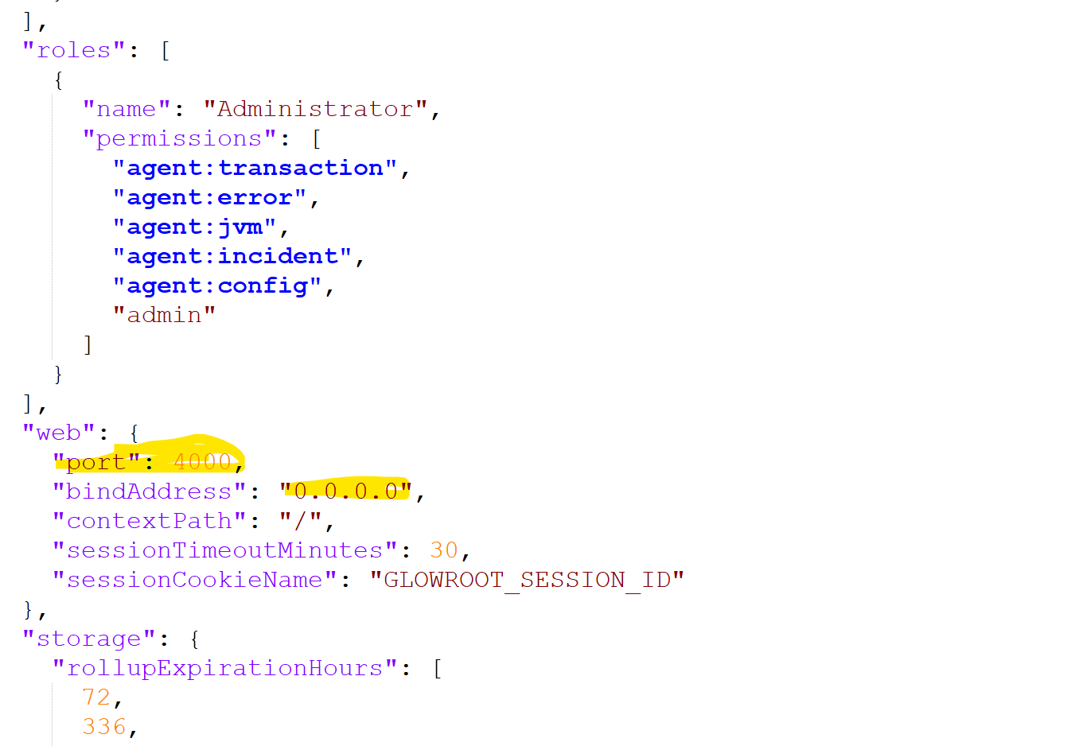

**Strep 6 :** Add**-javaagent:path/to/glowroot.jar** to your application servers' JVM arg

**-javaagent:/home/sigmastream/Tools/glowroot/Glowroot/glowroot.jar**

And then set this path on **Start-server.sh** file

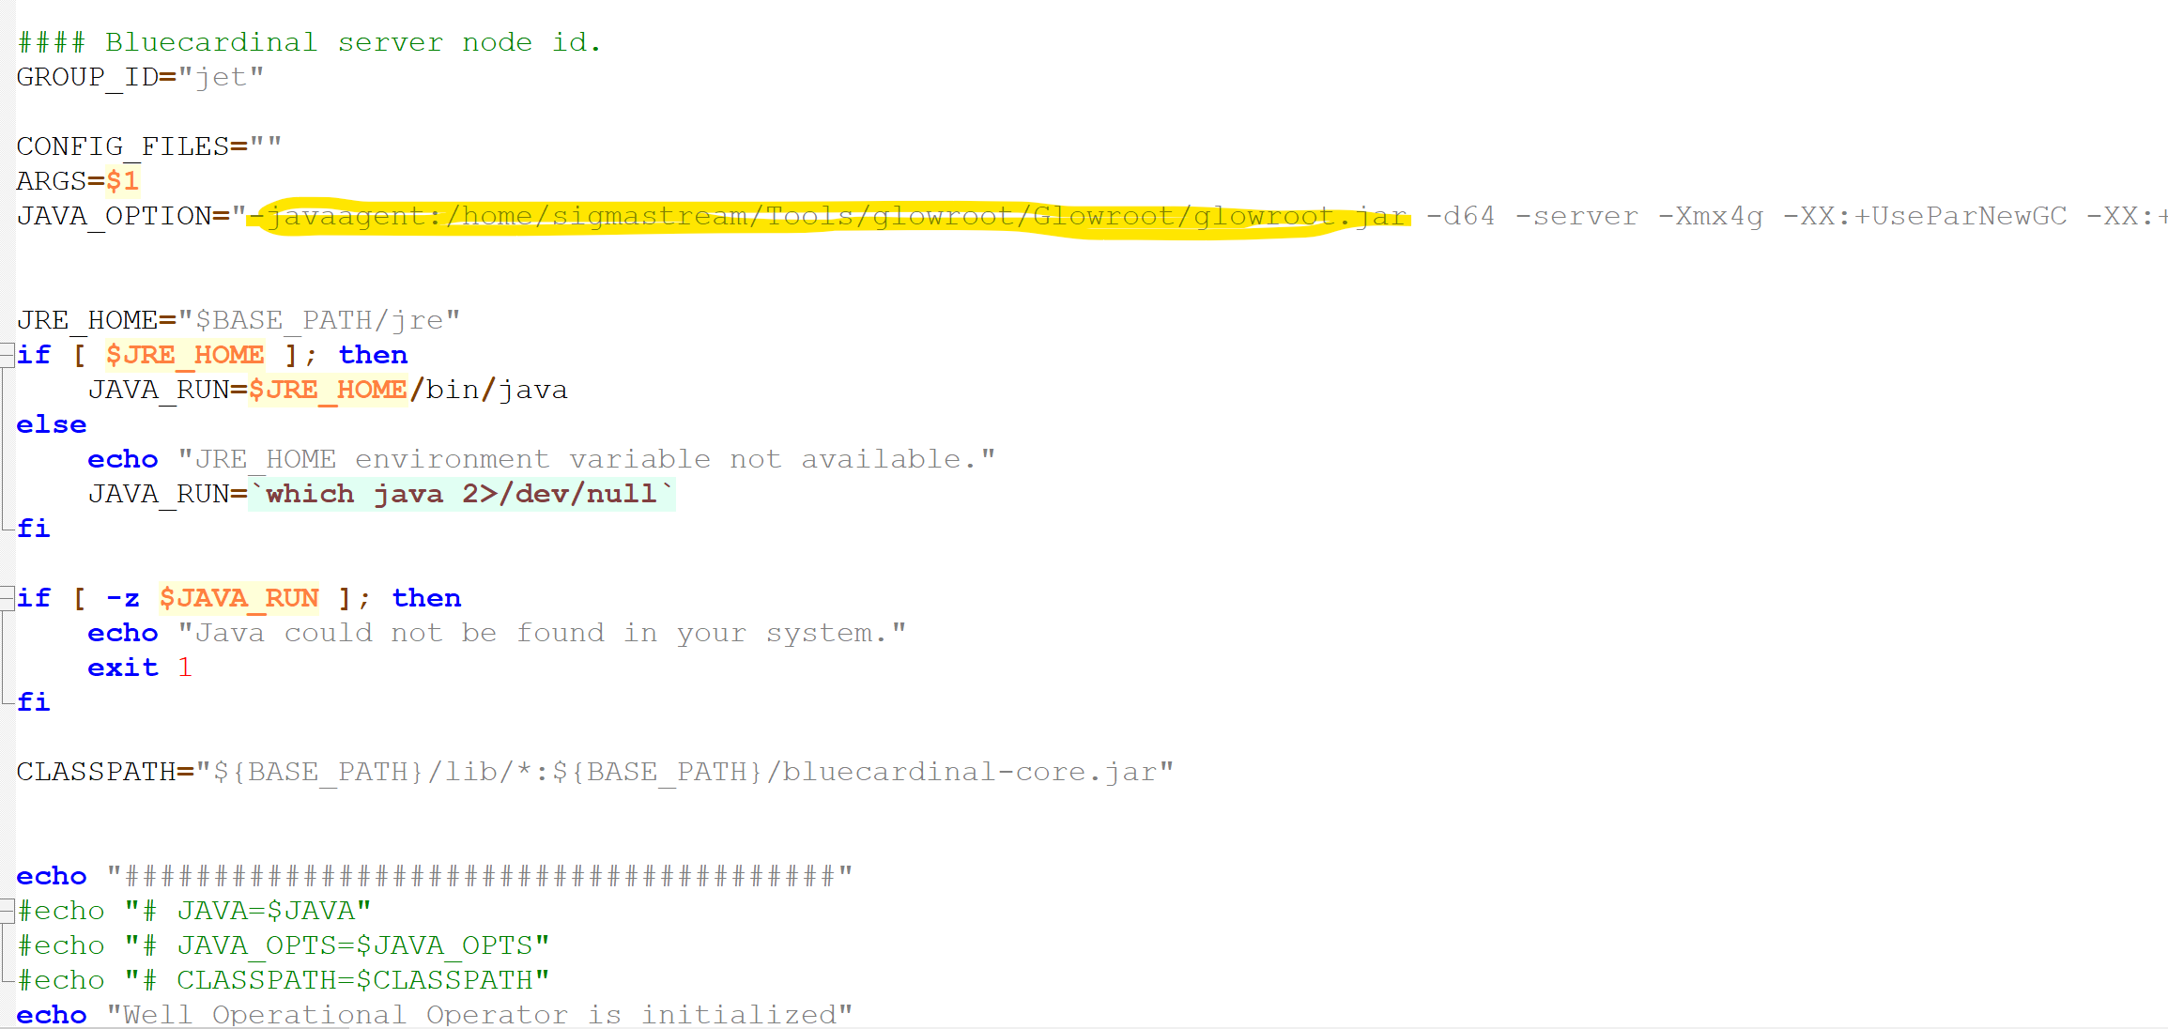

**Step 7:** try curl your url in terminal curl://0.0.0.0:4000

And in browser htpp://localhost:4000

